ASSESSMENT TOOL 1
CO3 AT1 EXPERIMENTS
NAME: CHANDRA KALA TORAM
REG NO: 192372224
COURSE CODE: CSA5110
COURSE NAME: CRYPTOGRAPHY AND NETWORK SECURITY

1. Develop a Python program to implement a Digital Signature scheme using RSA. Demonstrate message signing and signature verification, and analyze its effectiveness in ensuring integrity and authentication.
CODE:
import hashlib
import math
p = 61
q = 53
n = p * q
phi = (p - 1) * (q - 1)
e = 17
d = pow(e, -1, phi)
print("RSA Public Key (e, n):", (e, n))
print("RSA Private Key (d, n):", (d, n))
def sign_message(message):
hash_value = hashlib.sha256(message.encode()).hexdigest()
hash_integer = int(hash_value, 16)
signature = pow(hash_integer, d, n)
return signature
def verify_signature(message, signature):
hash_value = hashlib.sha256(message.encode()).hexdigest()
hash_integer = int(hash_value, 16)
decrypted_signature = pow(signature, e, n)
return decrypted_signature == (hash_integer % n)
test_messages = [
"Hello World",
"Digital Signature",
"RSA provides authentication",
"This is a secure message"
]
for i, message in enumerate(test_messages, 1):
print("\nTEST CASE", i)
print("Original Message:", message)
signature = sign_message(message)
print("Digital Signature:", signature)
if verify_signature(message, signature):
print("Verification: VALID")
else:
print("Verification: INVALID")
print("\nTAMPERED MESSAGE TEST")
message = "Hello World"
signature = sign_message(message)
tampered_message = "Hello World!"
print("Original Message:", message)
print("Tampered Message:", tampered_message)
print("Signature:", signature)
if verify_signature(tampered_message, signature):
print("Verification: VALID")
else:
print("Verification: INVALID")
OUTPUT:
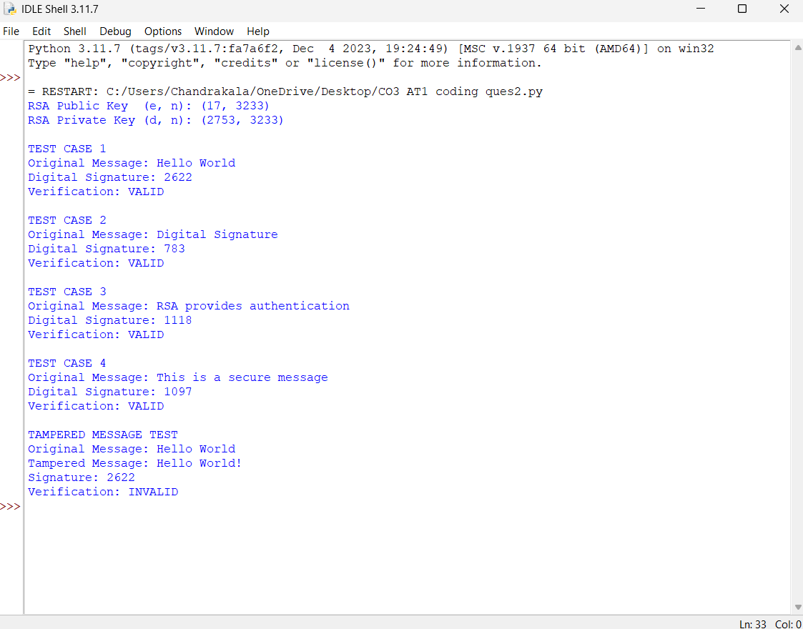
2. Write a Python program to compare MD5 and SHA-256 for the same input message.
Display:
Original message
MD5 digest
SHA-256 digest
Digest length
CODE:
import hashlib
def compare_hashes(message):
md5_hash = hashlib.md5(message.encode()).hexdigest()
sha256_hash = hashlib.sha256(message.encode()).hexdigest()
print("\n----------------------------------------")
print("Original Message:", repr(message))
print("\nMD5 Digest:")
print(md5_hash)
print("MD5 Digest Length:", len(md5_hash), "hex characters")
print("MD5 Digest Length:", len(bytes.fromhex(md5_hash)), "bytes")
print("\nSHA-256 Digest:")
print(sha256_hash)
print("SHA-256 Digest Length:", len(sha256_hash), "hex characters")
print("SHA-256 Digest Length:", len(bytes.fromhex(sha256_hash)), "bytes")
test_cases = [
"Hello World",
"Digital Signature",
"Hello",
"",
"Python Cryptography",
"This is a secure message",
"123456789"
]
for i, message in enumerate(test_cases, 1):
print("\n========== TEST CASE", i, "==========")
compare_hashes(message)
OUTPUT:
